Introduction to Robotics

Assignment I Conclusion

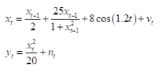

Given equations are non-linear and due to that, Kalman Filter cannot be used in this evaluation. Even tough, it is not used. A small implementation is attempted but scientifically, it is not correct. Kalman Filter is dealing only with Gaussian distributed random variables and linear systems.

However, Extended Kalman Filter and Particle Filters are beneficial in terms of non-linear systems.

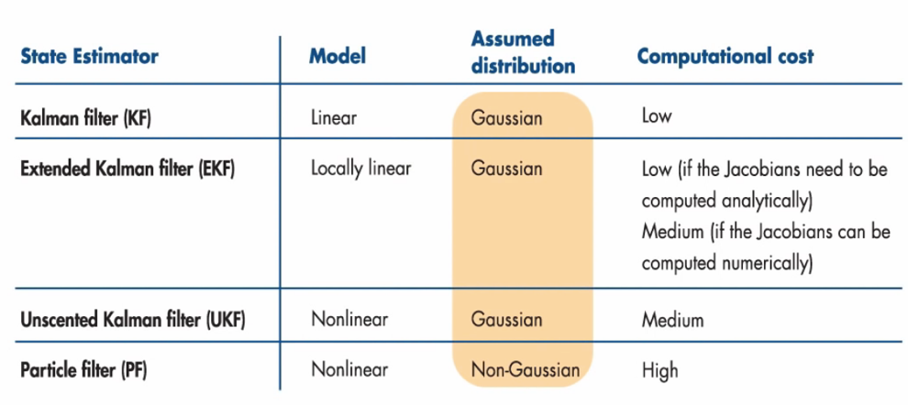



In this assignment, from given state-space equations, even tough, particle filter has higher run time complexity, particle filter is superior to EKF due to closer estimation.

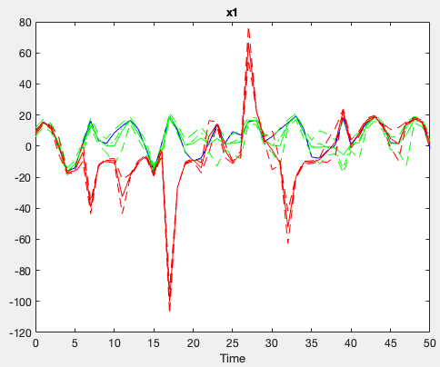

Uğur Can Kozan

150201025